Working Safely in the School Science Laboratories - Research
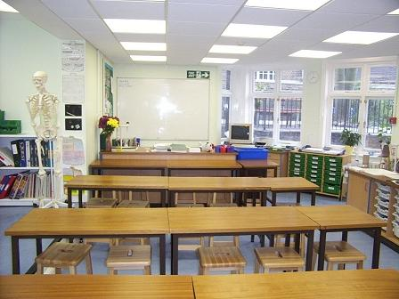

- What are the potential hazards in the school science labs? List 5 hazards
____________________________________________________________________________________________________________________________________________________________________________________________________________________________________________________________________________________________________________________________________________________________________________

- Find and identify 3 hazard warning signs in the science dept
____________________________________________________________________________________________________________________________________________________________________________________________________________________________________________________________________

- What is a risk assessment?
____________________________________________________________________________________________________________________________________________________________________________________________________________________________________________________________________

- Who carries out science lesson risk assessments?
____________________________________________________________________________________________________________________________________________________________

- What are the safety precautions for handling radioactive materials in school? _____________________________________________________________________________________________________________________________________________________________________________________________________________________________________________________________________________________________________________________________________________________________________

- How are unwanted radioactive materials disposed of safely?

________________________________________________________________________________________________________________________________________________________________________________________________________________________________________________________________________________________________________________________

- What first aid would you give to someone who:

- Had a heat burn or scald
____________________________________________________________________________________________________________________________________________________________________________________________________________________________________________________________________

- Had a chemical burn or scald
____________________________________________________________________________________________________________________________________________________________________________________________________________________________________________________________________

- Had an injury through breathing in fumes or swallowing chemicals? _______________________________________________________________________________________________________________________________________________________________________________________________________________________________________________________________

- Had an electric shock?
________________________________________________________________________________________________________________________________________________________________________________________________________________________

- Had cuts and damage to the eyes from particles or chemicals?
____________________________________________________________________________________________________________________________________________________________________________________________________________________________________________________________________

- In what situations would it be dangerous to give first aid? _______________________________________________________________________________________________________________________________________________________________________________________________________________________________________________________________

- Why is it so useful to have a first aid qualification?
________________________________________________________________________________________________________________________________________________________________________________________________________________________________________________________________________________________________________________________

- Which organisations give training for first aid? Who trains the first aiders in school?
____________________________________________________________________________________________________________________________________________________________________________________________________________________________________________________________________

- What must you do if you hear a fire alarm in school? _______________________________________________________________________________________________________________________________________________________________________________________________________________________________________________________________

- What must you do if you find a fire?

____________________________________________________________________________________________________________________________________________________________________________________________________________________________________________________________________

- How do fire doors function?
____________________________________________________________________________________________________________________________________________________________

- What are the different types of fire extinguisher?
____________________________________________________________________________________________________________________________________________________________________________________________________________________________________________________________________

- What are automated sprinkler systems and where might they be used?

____________________________________________________________________________________________________________________________________________________________

