Year 11 Additional Applied: What do I need to know?
FOOD SCIENCE

FOOD NUTRIENTS AND THEIR FUNCTIONS

- The human body needs many nutrients to carry out life functions such as respiration, movement, growth and repair
- Carbs provide energy
- Fats provide insulation, energy and store vitamins A, D, E & K
- Proteins repair and grow body tissues and provide some energy
- Vitamins
  - A- eyesight, keeps mucous membranes free from infection
  - B- releases energy from carbs, helps nerves to function
  - D- healthy teeth and bones, helps to absorb calcium and phosphorous
  - K- helps to clot blood
  - C- maintains skin and digestive system
- Minerals
  - Iron- helps to make haemoglobin which transports oxygen in red blood cells
  - Calcium for healthy teeth and bones
  - Phosphorus to aid the release of energy from food
  - Zinc for enzyme action and wound healing
- Symptoms of deficiencies
  - A- cannot adjust to dim light, dry skin and mucus membranes
  - B- anaemia, mouth sores, nerve cell degeneration
  - C- bleeding gums, poor healing of cuts, weak blood vessels
  - D- weak teeth and bones which can deform (rickets)
- Foods that are good sources
  - A- milk, eggs, carrots, spinach
  - B- potatoes, bananas, cereal, lentils, yeast
  - C- citrus fruits, potatoes, tomatoes
  - D- fish, egg, fortified cereal, dairy products
  - K- spinach, broccoli, cabbage
  - Iron- meat, fish, green veg
  - Phosphorus-dairy, meat, fish
  - Calcium- dairy, green leafy veg
  - Zinc- red meat, shellfish, seeds, green veg

- Too much …..
  - Saturated fat= heart disease
  - Sugar= diabetes
  - Salt= high blood pressure
- Fibre is important for removal of toxins and to keep the digestive system healthy
- To maintain the same weight your energy intake should = energy output

FOOD ADDITIVES

- Antioxidants (vit C)- preserve oil and fat in food
- Flavourings and flavour enhancers (monosodium glutamate)- give flavour
- Colourings (tartarzine)- add colour
- Preservatives (benzoic acid)- slow down spoilage process
- Sweeteners (aspartame)- add a sweet flavour
- Thickeners (starch)- increase thickness eg jam

- Advantages

  - Improved taste, appearance and shelf life

- Disadvantages
  - Some preservatives are toxic, tartrazine is linked to hyperactivity, allergic reactions

FOOD LABELS AND TESTS

- TEST FOR ……..
  - Starch = iodine which turns from brown to blue/black
  - Fat = add ethanol to a solution get milky layer
  - Protein = use buriets solution which goes from blue to purple
  - Sugar= Benedict’s solution then warm it will turn from blue to green, orange, red
  - Acidity= universal indicator

MICROBES IN FOOD

- Bread production- yeast is added. Yeast converts sugar into carbon dioxide and some ethanol. The carbon dioxide makes the bread rise
- Wine – grapes are crushed and yeast is added to convert sugar into alcohol
- Beer- grains are mashed up and yeast is added to convert sugar into alcohol
- Yoghurt- equipment is sterilised to kill off unwanted bacteria. Milk is pasteurised (heated) to kill off bacteria and then allowed to cool. Bacteria is added in the mixture is left to ferment. The bacteria convert lactose sugar in the milk into lactic acid. This causes the milk to solidify and turn to yoghurt
- Cheese- bacteria is added to warm milk to produce solid curds in the milk. The curds are separated from liquid whey. Bacteria now ripen the curds or moulds are added to make blue cheese.

FOOD SAFETY
- Food poisoning is caused by the growth of microbes and by the toxins they give out when they grow. Public health inspectors monitor food poisoning outbreaks
- Bacteria that cause food poisoning
  - Campylobacter
  - E. Coli
  - Salmonella
- Bacteria grow best in warm, moist conditions with a good food source
- Symptoms of food poisoning are stomach pains, diarrhoea and vomiting
- Food preparation areas are kept free from bacteria by good personal hygiene, disinfectants, detergents, sterilisation, disposal of waste, control of pests
- We slow the growth of bacteria by
  - Refrigeration
  - Freezing
  - Heating
  - Drying
  - Salting
  - Pickling

ORGANIC AND INTENSIVE FARMING

- As crops grow they remove essential nutrients from the soil which then need to be replaced
- Plants need
  - Nitrates- to make proteins to grow
  - Phosphates- for respiration and growth
  - potassium – for photosynthesis and respiration
  - magnesium – for photosynthesis
- Intensive farming increases crop yields by
  - Artificial fertilisers
  - Pesticides
  - Herbicides
  - fungicides
- Intensive farming increases meat production by using controlled environments for pigs/ hens e.g. lots of heat and light, no room to move so all their energy goes to getting bigger
- Organic farms use natural fertilisers, natural pesticides (e.g. other insects), mechanical methods of removing weeds
- Animals on organic farms have outdoor pens, room to move, natural light

FOOD SCIENCE: HOW DO I ……….

MEASURE MOISTURE CONTENT

- measure initial mass
- heat in an oven
- until mass is constant
- record new mass
- calculate % water

SUSPENDED MATTER BY FILTRATION

- measure 100ml of drink
- filter
- dry the filter paper
- measure the mass of the residue
- work out suspended matter in grams per litre by multiplying by 10

ACIDITY BY TITRATION

- Add 25cm3 of vinegar to a beaker and make up to 250cm3 with distilled water
- pipette 25cm3 of this sample into a conical flask and add some universal indicator
- fill a burette with sodium hydroxide (alkali)
- Titrate into the conical flask until the colour changes

VITAMIN C CONTENT OF FOOD
YOU SHOULD KNOW THIS- its your coursework practical

IRON CONTENT OF FOOD

- dilute iron chloride solution to 0.1%, 0.01%, 0.001%, 0.0001%, 0.00001%
- Pour 5ml of each solution into a test tube and add KSCN solution to it (it will turn redder the more iron)
- take your food sample and heat it till it burns
- add this to water and filter
- add KSCN
- compare your colour to the standard solution and estimate the concentration of iron
MAKE A SERIAL DILUTION TO COUNT BACTERIA

- Dilute your sample eg 1cm3 of solution with 9cm3 of water this is now diluted by 10
- to dilute by 100, take 1cm3 of the diluted by 10 solution and add 9cm3 of water
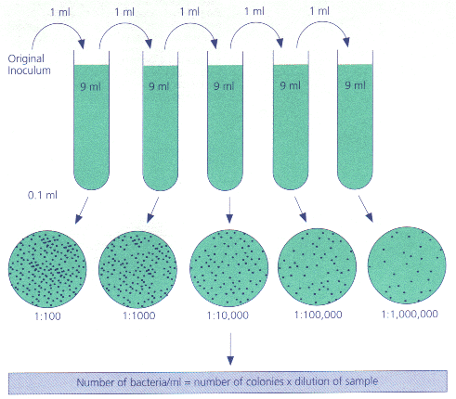

- Add some of the solution to an agar plate and leave to grow
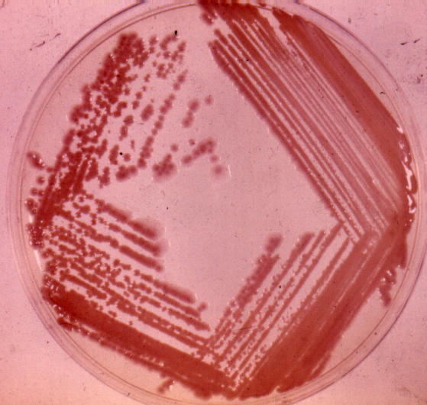
- count the colonies and multiply by the dilution factor e.g. if the solution that has been diluted by 1000 gave 20 colonies = 1000 X 20 = 20 000

MAKE A STREAK PLATE
- flame a wire in a Bunsen
- dip the wire into the sample of bacteria
- spread over an agar plate
- incubate (leave to grow in warm conditions)

CARRY OUT ASEPTIC TECHNIQUE
- Sterilise equipment
- keep lids on bottles closed and when opening keep open for as little as possible
- pass the top of bottles through a Bunsen flame once opened
- don’t put lids down on benches
- seal agar plates with tape
- dispose of equipment by pressure sterilising in an autoclave

