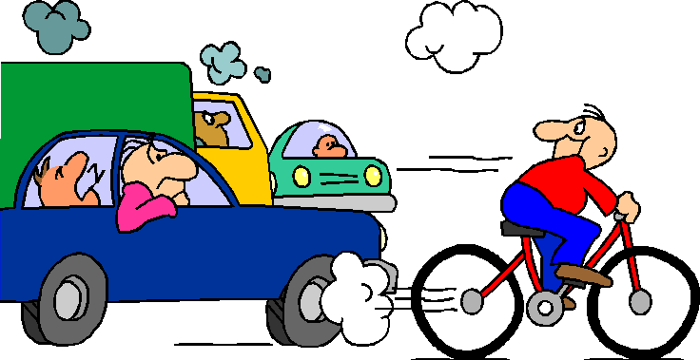
GCSE Science Unit – 13

Topic: Motion

Activity: Transport

Spec Refs: 13.2

Pages: 49
Objectives (including specific refs to HSW):
- Appreciate the impact of transport in the modern world
- Relate how the desire for speed creates problems and proposed solutions

Outcomes:
Pupils survey of the effects of modern means of transport
Pupils produce a point of view on a transport issue and relate it to speed (presentation)

Suggested Activities (including specific refs to HSW):

Starter: Make two lists of means of transport; one which you consider harmful in some important way and the other for those which are usually less harmful.

Main:
- Go through the list of means of transport bringing out the following
    - deaths and injuries (e.g. road accidents, plane crashes etc.)
    - expense (e.g. cost of road building, traffic police, speed cameras etc.)
    - congestion on the roads (e.g. time wasted in traffic jams)
    - consumption of natural resources (e.g. non-renewable fossil fuels)
    - pollution of the environment (e.g. smog and health)
    - global warming (due to increases in carbon dioxide levels)

- Groups of 2/3 pupils choose an issue to discuss and produce a brief presentation for the class which they give if time allows. They need to include the following
    - how speed is involved in the problem they are considering
    - a point of view on the best way of solving the problem
    - how they expect the world to be different in 50 years time in relation to the problem they are discussing.

Use data (e.g. from a computer simulation) about the speed of an object (e.g. car) moving in a straight line to plot the velocity as a function of time (See also Motion 2.1 sheet). Use the graph to find:
The distance moved during various stages of the motion.

Plenary: Review of all the characteristics of velocity-time graphs. Graphs on page 189 can be used as the basis of a quick quiz.

Apparatus / Materials Required
Nelson Thornes AQA Science
Motion Resource Pack 1

Safety:
No hazards

References:
Nelson Thornes p192-3, p195 lilac box
Differentiation
Extension: Consider the effects of speed on fuel consumption.
Support: Why is a bicycle better than a car?

Homework ideas: Exam-type question.
Summary and exam-style questions on p194-5 (photocopies needed)
On-line test: http://www.bustertests.co.uk/take_test/50

