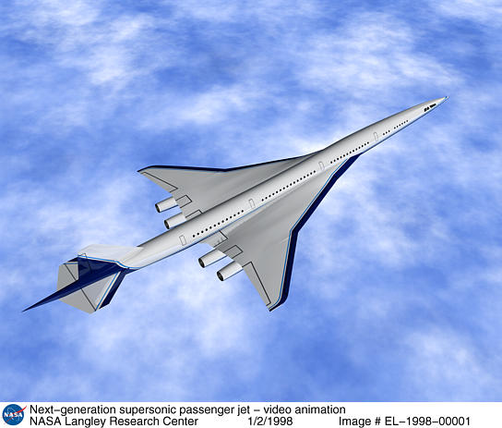
GCSE Science Unit – 13

Topic: Motion

Activity: Speed, velocity and acceleration

Spec Refs: 13.2

Pages: 49
Objectives (including specific refs to HSW):
- Distinguish between speed and velocity; acceleration (meaning, evaluation, units)
- Displaying (change in) speed as a graph (velocity-time)

Outcomes:
Construction of velocity-time graphs from data
Extracting information from velocity-time graphs, calculations with correct units

Suggested Activities (including specific refs to HSW):

Starter: Crossword on motion

Main: Discuss the difference between speed and velocity including examples of cars moving at the same speed but in different directions and an object moving a constant speed but continuously changing direction.

Use data (e.g. from a computer simulation) about the speed of an object (e.g. car) moving in a straight line to plot the velocity as a function of time (See also Motion 2.1 sheet). Use the graph to find:
- Times when the object is stationary, moving with constant speed, speeding up and slowing down
- The average acceleration between two times (= change in velocity/time taken)
- The acceleration at any particular time (gradient = acceleration)

Plenary: Class hold up true/false cards in reply to teacher’s questions (e.g. about graph shown on page 187)

Apparatus / Materials Required
Simulation/data, Motion Sheets 2.1, 2.2
True/False cards, Nelson Thornes AQA Science
Motion Resource Pack 1

Safety:
No hazards

References:
Nelson Thornes p186-7
Motion Resource Pack 1

Differentiation
Extension: Draw curved v-t graphs to produce tables; find instantaneous accelerations from tangents.
Support: Speedometer readings sheet Motion 2.2.

Homework ideas: Create advertising leaflet for a new car selling its top speed and acceleration (Home IT opportunity).

