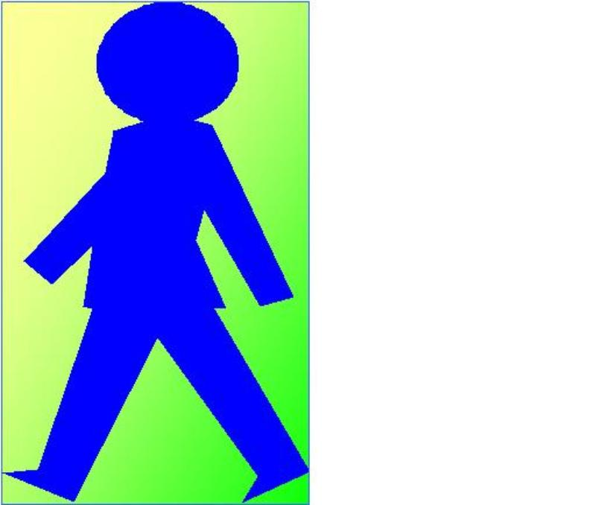
GCSE Science Unit – 13

Topic: Motion

Activity: Distance, time and speed

Spec Refs: 13.1

Pages: 49

Objectives (including specific refs to HSW):
- Recording the position of a (moving) object as time passes (tables)
- Displaying the record of motion as a graph

Outcomes:
Construction of distance-time graphs from data
Extracting information from distance-time graphs

Suggested Activities (including specific refs to HSW):

Starter: Put a list of moving objects in order of assessed speed from snail to light.

Main: Use a moving object (e.g. robocar, rolling ball etc.) to collect data about the position of an object measured from a fixed reference point. Repeat and average if possible. Use the tabulated data to draw a distance-time graph. Use the graph to find:

- The average speed of the object ( = total distance moved / total time taken)

- The nature of the motion at different stages (e.g. constant speed = straight line, accelerating = curve upwards, slowing down = curve downwards, stopped = flat line)

- The speed at any particular time (gradient = speed)

Plenary: Class hold up true/false cards in reply to teacher’s questions (e.g. about graphs shown on pages 184,185)

Apparatus / Materials Required
Robocars, stopwatches, metre rules, true/false cards, Nelson Thornes AQA Science
Motion Resource Pack 1

Safety:
Take care that robocars do not fall off the bench onto feet.

References:
Nelson Thornes p184-5
Motion Resource Pack 1

Differentiation
Extension: Draw tangents on curved graphs to find instantaneous speed.
Support: Draw position of snail on a road at 1 minute intervals.

Homework ideas: Plan a simple experiment you could do to find your average walking speed, and do it.

