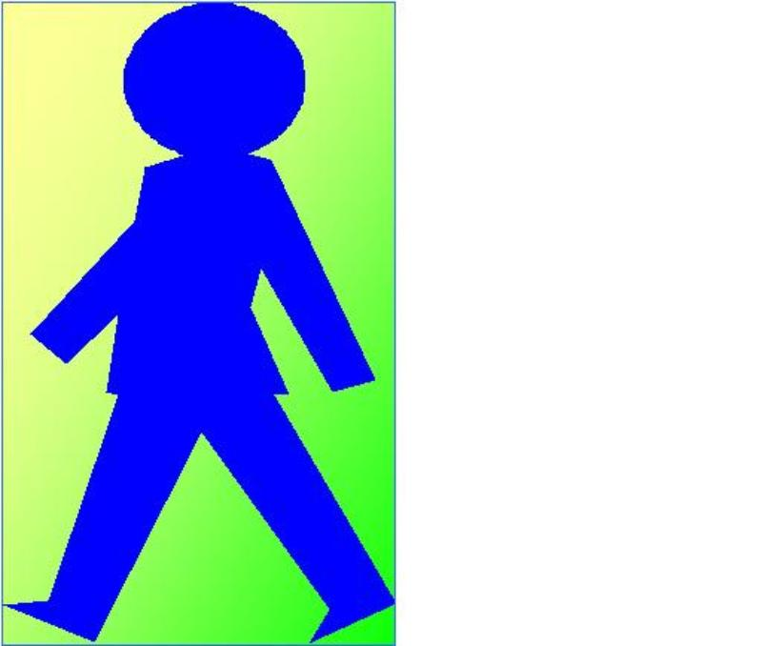
GCSE Science Unit – 13

Topic: Mains Electricity

Activity: Fuses and Earth Connections

Spec Refs: 13.7

Pages: 54-5

Objectives (including specific refs to HSW):
- Understand the purpose, operation and rating of fuses, other circuit breakers
- Know why and how some appliances are earthed

Outcomes:
Correctly place a fuse in the live line of circuit and choose the correct rating.
Add an earth wire in circuits where needed.

Suggested Activities (including specific refs to HSW):

Starter: Write down the names and colours of the wires in a 3-pin plug and describe where they are connected.
Main: Emphasising that mains electricity can easily kill describe/show the precautions that are taken to protect the user:
- Cables have double insulation and the wires are colour coded for easy identification
- 3-pin plugs are made of strong insulating plastic
- Many appliances have an outer casing made of an insulating material such as plastic. Appliances with a metallic casing are earthed
- Fuses are fitted to the live line to cut off the current if it becomes too large to be safe
- Circuit breakers perform a similar function to fuses but can be reset easily
Demonstrate the heating effect of a current. Use diagrams to show the placement of the fuse in the live line and the earth wire as separate from the current-carrying circuit. Use examples of fuses with correct rating (a little larger than normal current taken) and pupils make choices for values given normal current data.
Plenary: True or false quick quiz (See p260-1 for ideas).

Apparatus / Materials Required
A selection of mains appliances and fuses of different ratings
Nelson Thornes AQA Science (Additional)
Safety:
Pupils are not to use mains electricity

References:
Nelson Thornes AQA Science (Additional) p250 - 251

Differentiation
Extension: Find out how circuit breakers work.
Support: Design a poster warning of the dangers of using the incorrect fuse.

Homework ideas: Write a letter to your uncle explaining why he should get a qualified electrician to rewire his house rather than do it himself.

